**Angular 12 CRUD Example with Web API – HttpClient REST APIs with fake**

**Json Server**

78.3K

Could Elon Musk become a trillionaire by 2024?

**Next**

**Stay**

Angular applications are data-centric, which needs to connect with a server to store and fetch data. In Angular, we achieve the server communication channel through the HttpClientModule API service.

This Angular post is compatible with Angular 4 upto latest versions, Angular 7, Angular 8, Angular 9, Angular 10, Angular 11 & Angular 12

**Summary of content**

[1) Introduction of our Angular application](https://www.freakyjolly.com/angular-12-crud-example-with-web-api-httpclient-rest-apis/#Introduction_of_our_Angular_application)

[2) Structure of Application](https://www.freakyjolly.com/angular-12-crud-example-with-web-api-httpclient-rest-apis/#Structure_of_Application)

[3) Adding Mock Server for our Application](https://www.freakyjolly.com/angular-12-crud-example-with-web-api-httpclient-rest-apis/" \l "Adding_Mock_Server_for_our_Application)

[3.1) Install json-server](https://www.freakyjolly.com/angular-12-crud-example-with-web-api-httpclient-rest-apis/#Install_json-server)

[3.2) Create a JSON file](https://www.freakyjolly.com/angular-12-crud-example-with-web-api-httpclient-rest-apis/#Create_a_JSON_file)

[3.3) Start mock server](https://www.freakyjolly.com/angular-12-crud-example-with-web-api-httpclient-rest-apis/#Start_mock_server)

[4) Step 1: Create a new Angular application](https://www.freakyjolly.com/angular-12-crud-example-with-web-api-httpclient-rest-apis/#Step_1_Create_a_new_Angular_application)

[5) Step 3: Refactor the AppModule](https://www.freakyjolly.com/angular-12-crud-example-with-web-api-httpclient-rest-apis/#Step_3_Refactor_the_AppModule)

[6) Step 4: Update Angular Application Routes.](https://www.freakyjolly.com/angular-12-crud-example-with-web-api-httpclient-rest-apis/#Step_4_Update_Angular_Application_Routes)

[7) Step 5: Adding Bootstrap in Angular application](https://www.freakyjolly.com/angular-12-crud-example-with-web-api-httpclient-rest-apis/#Step_5_Adding_Bootstrap_in_Angular_application)

[8) Step 6: Add Bootstrap Navigation Bar to Route between Views](https://www.freakyjolly.com/angular-12-crud-example-with-web-api-httpclient-rest-apis/#Step_6_Add_Bootstrap_Navigation_Bar_to_Route_between_Views)

[9) Step 7: Refactor the Books Service to Handle HTTP Calls](https://www.freakyjolly.com/angular-12-crud-example-with-web-api-httpclient-rest-apis/#Step_7_Refactor_the_Books_Service_to_Handle_HTTP_Calls)

[10) Step 8: Refactor the Angular Components](https://www.freakyjolly.com/angular-12-crud-example-with-web-api-httpclient-rest-apis/#Step_8_Refactor_the_Angular_Components)

[10.1) Creating or Adding New Book](https://www.freakyjolly.com/angular-12-crud-example-with-web-api-httpclient-rest-apis/#Creating_or_Adding_New_Book)

[10.2) Show List of All Books](https://www.freakyjolly.com/angular-12-crud-example-with-web-api-httpclient-rest-apis/#Show_List_of_All_Books)

[10.3) Book Details Component](https://www.freakyjolly.com/angular-12-crud-example-with-web-api-httpclient-rest-apis/#Book_Details_Component)

[11) Step 9: Serve or Run Application in the Browser](https://www.freakyjolly.com/angular-12-crud-example-with-web-api-httpclient-rest-apis/#Step_9_Serve_or_Run_Application_in_the_Browser)

[12) Conclusion](https://www.freakyjolly.com/angular-12-crud-example-with-web-api-httpclient-rest-apis/#Conclusion)

**Introduction of our Angular application**

We are going to build an Angular application, that will store and fetch **Books details** using RESTfull API web services.  Besides this, our application will have the following features:

* Users will be able to Create new book records, Edit/ Update any existing item.
* Any item can be deleted by providing the ID of the mapped book.
* The search filter will show the list of matching book titles.

Let’s start with building our app.

**Structure of Application**

In our Angular application, we’ll create new Components including ListComponent, DetailsComponent and CreateComponent. Moreover to handle the HTTP Services and connect with Web services, we’ll create a service named BooksService.

These components will be shown on specific routes, for that we’ll also configure the App Routing Module.

For adding the style to our application, we’ll be using the Bootstrap 4 style component.

**Adding Mock Server for our Application**

We can easily set up a local mock server by installing the json-server package. This will help up to quickly test our application performing CRUD operations by using a JSON file.

**Install json-server**

Run the npm command to install the json-server package globally.

$ npm install -g json-server

Copy

**Create a JSON file**

Next, create a data.json file inside the **app/data.json**  this file will keep the data that will be used for CRUD operations.

Add the following property in **data.json** file

{

"books":[]

}

Copy

**Start mock server**

Finally, run the mock server in new CLI instance with json file specified using below command

$ json-server --watch ./src/app/data.json

\{^\_^}/ hi!

Loading ./src/app/data.json

Done

Resources

http://localhost:3000/books

Home

http://localhost:3000

Type s + enter at any time to create a snapshot of the database

Watching...

Copy

Following are the API URLs that will be available on our server:

* GET /books– fetch all books
* GET /books/: id – fetch a single book detail by id
* POST /books – create a new book
* PUT /books/: id – update a book by id
* PATCH /books/: id – partially update a book by id
* DELETE /books/:id – delete a book by id
* GET /books?title\_like=text – filter the list of books with title name provided.

**Step 1: Create a new Angular application**

Moving to create an application, make sure you have the latest version of Angular CLI installed

npm install -g @angular/cli

Copy

After that, create a new angular project by executing ng command

ng new angular-crud-app

Copy

It will ask a few questions:

* Would you like to add Angular routing? – Select **Yes** as we need Routing for our application.
* Which stylesheet format would you like to use? – We will go for **SCSS**, but you can choose any.

Get inside the project directory

cd angular-crud-app

Copy

Step 2: Generate the required Components and Service

To better showcase the application features, we’ll show CRUD operation in separate views. Also, we’ll have a books service to manage the HTTP Web services.

Execute the following generate commands to create components and service using the Angular CLI tool.

ng generate service services/books

ng generate component components/create

ng generate component components/details

ng generate component components/list

Copy

The above commands will create the following components in the **app/components** folder. Angular CLI will auto-register these components in AppModule of the application.

* CreateComponent – Will have a form to create new Books.
* DetailsComponent – Show details of each selected Book.
* ListComponent – This will show a list of all or searched Books.

A service named BooksService is also created in the services folder. This service will manage the CRUD operations and error handling of API calls.

**Step 3: Refactor the AppModule**

Our Angular application will be having Forms to perform CRUD operations, so we need to import the FormsModule.

Also to communicate with Web services and make HTTP calls, we’ll import HttpClientModule.

Open the **app.module.ts** file and update as shown below:

import { NgModule } from '@angular/core';

import { BrowserModule } from '@angular/platform-browser';

import { AppRoutingModule } from './app-routing.module';

import { AppComponent } from './app.component';

import { CreateComponent } from './components/create/create.component';

import { DetailsComponent } from './components/details/details.component';

import { ListComponent } from './components/list/list.component';

import { FormsModule } from '@angular/forms';

import { HttpClientModule } from '@angular/common/http';

@NgModule({

declarations: [

AppComponent,

CreateComponent,

DetailsComponent,

ListComponent

],

imports: [

BrowserModule,

AppRoutingModule,

FormsModule,

HttpClientModule

],

providers: [],

bootstrap: [AppComponent]

})

export class AppModule { }

Copy

**Step 4: Update Angular Application Routes.**

While creating the Angular application, we selected Yes to create Routing. Due to that we already have the **app-routing.module.ts** file in the **app** folder.

Next, we need to update this file to add more routes to show our newly created components as shown below:

import { NgModule } from '@angular/core';

import { RouterModule, Routes } from '@angular/router';

import { CreateComponent } from './components/create/create.component';

import { DetailsComponent } from './components/details/details.component';

import { ListComponent } from './components/list/list.component';

const routes: Routes = [

{ path: '', redirectTo: 'books', pathMatch: 'full' },

{ path: 'books', component: ListComponent },

{ path: 'book/:id', component: DetailsComponent },

{ path: 'add', component: CreateComponent }

];

@NgModule({

imports: [RouterModule.forRoot(routes)],

exports: [RouterModule]

})

export class AppRoutingModule { }

Copy

**Step 5: Adding Bootstrap in Angular application**

To quickly style our application, we can include the **bootstrap.min.css** file in the <head> section of **index.html** as shown below.

<!doctype html>

<html lang="en">

<head>

<meta charset="utf-8">

<title>AngularCrudApp</title>

<base href="/">

<meta name="viewport" content="width=device-width, initial-scale=1">

<link rel="icon" type="image/x-icon" href="favicon.ico">

<link rel="stylesheet" href="https://maxcdn.bootstrapcdn.com/bootstrap/4.0.0/css/bootstrap.min.css">

</head>

<body>

<app-root></app-root>

</body>

</html>

Copy

**Step 6: Add Bootstrap Navigation Bar to Route between Views**

Next, we’ll update the App Component to create Navigation links on top using Bootstrap stylings.

Open the **app.component.html** file and update it with this code:

<div>

<nav class="navbar navbar-expand navbar-dark bg-primary">

<a href="#" class="navbar-brand">Freaky Jolly</a>

<div class="navbar-nav mr-auto">

<li class="nav-item" routerLink="books" routerLinkActive="active">

<a href="javascript:void(0)" class="nav-link">List of Books</a>

</li>

<li class="nav-item" routerLink="add" routerLinkActive="active">

<a href="javascript:void(0)" class="nav-link">Add a Book</a>

</li>

</div>

</nav>

<div class="container mt-5">

<router-outlet></router-outlet>

</div>

</div>

Copy

Above, you will notice routerLink directives, which are used to link between views and helps in routing the pages. The router-outlet will be the container of our view or components.

**Step 7: Refactor the Books Service to Handle HTTP Calls**

Now, we’ll focus on the main component of our application, the BooksService. Our service will use the HttpClient class to expose various HTTP methods to make REST API calls.

Open the **services/books.service.ts** file and update it

import { HttpClient, HttpErrorResponse, HttpHeaders } from '@angular/common/http';

import { Injectable } from '@angular/core';

import { catchError } from 'rxjs/operators';

import { Observable, throwError } from 'rxjs';

@Injectable({

providedIn: 'root'

})

export class BooksService {

apiUrl: string = 'http://localhost:3000/books';

headers = new HttpHeaders().set('Content-Type', 'application/json');

constructor(private httpClient: HttpClient) { }

// Show lists of item

list(): Observable<any> {

return this.httpClient.get(this.apiUrl).pipe(

catchError(this.handleError)

);

}

// Create new item

getItem(id: any): Observable<any> {

return this.httpClient.get(`${this.apiUrl}/${id}`).pipe(

catchError(this.handleError)

);

}

create(data: any): Observable<any> {

return this.httpClient.post(this.apiUrl, data).pipe(

catchError(this.handleError)

);

}

// Edit/ Update

update(id: any, data: any): Observable<any> {

return this.httpClient.put(`${this.apiUrl}/${id}`, data).pipe(

catchError(this.handleError)

);

}

// Delete

delete(id: any): Observable<any> {

return this.httpClient.delete(`${this.apiUrl}/${id}`).pipe(

catchError(this.handleError)

);

}

// Search By Name

filterByTitle(title: any): Observable<any> {

return this.httpClient.get(`${this.apiUrl}?title\_like=${title}`).pipe(

catchError(this.handleError)

);

}

// Handle API errors

handleError(error: HttpErrorResponse) {

if (error.error instanceof ErrorEvent) {

console.error('An error occurred:', error.error.message);

} else {

console.error(

`Backend returned code ${error.status}, ` +

`body was: ${error.error}`);

}

return throwError(

'Something bad happened; please try again later.');

};

}

Copy

**Step 8: Refactor the Angular Components**

Next, we’ll update the components which we create on starting of our tutorial.

**Creating or Adding New Book**

The CreateComponent will have a form to create a new Book with details including Title and Description.

Update the **components\create\create.component.html** file with the following code having Bootstrap styles.

<div style="width: 500px; margin: auto;">

<div class="submit-form">

<div \*ngIf="!isBookAdded">

<div class="form-group">

<label for="title">Title</label>

<input type="text" class="form-control" id="title" required [(ngModel)]="book.title" name="name" />

</div>

<div class="form-group">

<label for="description">Description</label>

<input class="form-control" id="description" required [(ngModel)]="book.description" name="description" />

</div>

<button (click)="addBook()" class="btn btn-success">Create</button>

</div>

<div \*ngIf="isBookAdded">

<h3>New book added!</h3>

<button class="btn btn-success" (click)="newBook()"> + Add More</button>

</div>

</div>

</div>

Copy

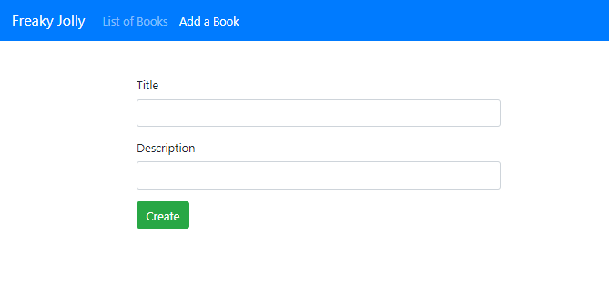

In the Component class, we’ll inject our BooksService to use its create() method.

Open the **components\create\create.component.ts** and update with the following code.

import { Component, OnInit } from '@angular/core';

import { BooksService } from 'src/app/services/books.service';

@Component({

selector: 'app-create',

templateUrl: './create.component.html',

styleUrls: ['./create.component.scss']

})

export class CreateComponent implements OnInit {

book = {

title: '',

description: ''

};

isBookAdded = false;

constructor(private booksService: BooksService) { }

ngOnInit(): void { }

// Add New

addBook(): void {

const data = {

title: this.book.title,

description: this.book.description

};

if (!data.title) {

alert('Please add title!');

return;

}

this.booksService.create(data)

.subscribe(

response => {

console.log(response);

this.isBookAdded = true;

},

error => {

console.log(error);

});

}

// Reset on adding new

newBook(): void {

this.isBookAdded = false;

this.book = {

title: '',

description: ''

};

}

}

Copy

**Show List of All Books**

On the List Component page a user can perform the following operations:

* Deletes single book
* Delete all books at once
* Search for titles of books

We’ll inject the BooksService and call its methods from template HTML. The list of all books will be fetched to show-up details in the table format. In that table, each row will also have **Edit** and **Delete** user actions. On clicking the Edit button user will simply redirect to the details route link i.e /book/:id.

The search bar can be used to fetch a filtered list of records. Open the **list.component.html** file and update with the following code.

<div class="list row">

<div class="col-md-8">

<div class="input-group mb-4">

<input type="text" class="form-control" placeholder="Search by title" [(ngModel)]="searchTitle" />

<div class="input-group-append">

<button class="btn btn-outline-secondary" type="button" (click)="searchByTitle()">

Search

</button>

</div>

</div>

</div>

<div class="col-md-12">

<h4>Book List</h4>

<table class="table">

<thead>

<tr>

<th scope="col">#</th>

<th scope="col">Title</th>

<th scope="col">Description</th>

<th scope="col" style="min-width: 150px;">Action</th>

</tr>

</thead>

<tbody>

<tr \*ngFor="let book of books;">

<th scope="row">{{book.id}}</th>

<td><b>{{book.title}}</b></td>

<td>{{book.description}}</td>

<td>

<button type="button" class="btn btn-danger" routerLink="/book/{{book.id}}">Edit</button>

<button type="button" class="btn btn-warning" (click)="deleteBook(book.id)">Delete</button>

</td>

</tr>

</tbody>

</table>

</div>

</div>

Copy

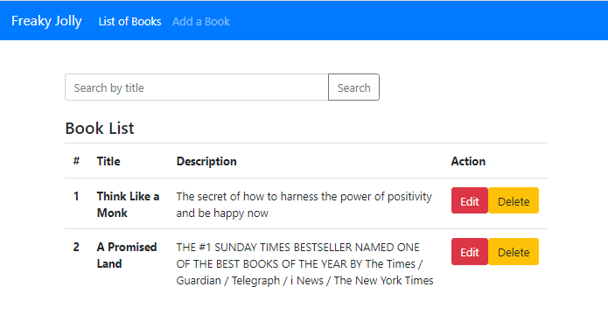

After adding the template HTML, update the component class with methods defined. Open the **list.component.ts** file and update

import { Component, OnInit } from '@angular/core';

import { BooksService } from 'src/app/services/books.service';

@Component({

selector: 'app-list',

templateUrl: './list.component.html',

styleUrls: ['./list.component.scss']

})

export class ListComponent implements OnInit {

books: any;

currentBook:any;

currentIndex = -1;

searchTitle = '';

constructor(private booksService: BooksService) { }

ngOnInit(): void {

this.getAllBooks();

}

// Get list

getAllBooks(): void {

this.booksService.list()

.subscribe(

(books: any) => {

this.books = books;

},

(error: any) => {

console.log(error);

});

}

// Delete action

deleteBook(id:number){

this.booksService.delete(id)

.subscribe(

response => {

this.getAllBooks();

},

error => {

console.log(error);

});

}

// Search items

searchByTitle(): void {

this.booksService.filterByTitle(this.searchTitle)

.subscribe(

books => {

this.books = books;

},

error => {

console.log(error);

});

}

}

Copy

**Book Details Component**

Finally, we have the Details component, which will display the details of the selected book from the list page. The Details component will show bu on /book/:id route URL from where the id will be used to fetch its details.

The details will be shown in a prepopulated form, having button to Update or Delete the book.

Open the **details.component.html** file and update it with the following code.

<div style="width: 500px; margin: auto;">

<div \*ngIf="currentBook" class="edit-form">

<h4>Book</h4>

<form>

<div class="form-group">

<label for="title">Title</label>

<input

type="text"

class="form-control"

id="name"

[(ngModel)]="currentBook.title"

name="name"

/>

</div>

<div class="form-group">

<label for="description">Description</label>

<input

type="text"

class="form-control"

id="description"

[(ngModel)]="currentBook.description"

name="description"

/>

</div>

</form>

<button type="button" class="btn btn-danger" (click)="updateBook()" >Update</button>

<button type="button" class="btn btn-warning" (click)="deleteBook()">Delete</button>

</div>

</div>

Copy

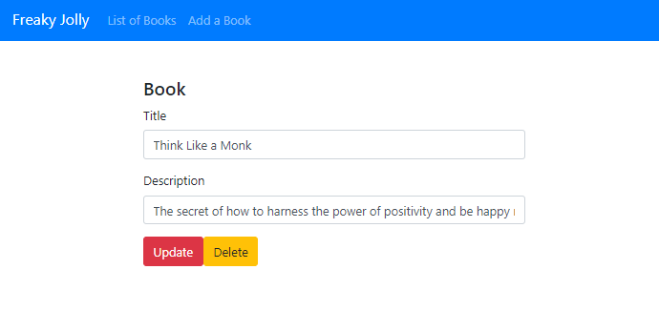

After that update the component class to fetch book details by getting the id from the route URL by using the ActivatedRoute and Route class.

Open the **details.component.ts** file and update it with the following code.

import { Component, OnInit } from '@angular/core';

import { ActivatedRoute, Router } from '@angular/router';

import { BooksService } from 'src/app/services/books.service';

@Component({

selector: 'app-details',

templateUrl: './details.component.html',

styleUrls: ['./details.component.scss']

})

export class DetailsComponent implements OnInit {

currentBook: any;

message = '';

constructor(

private booksService: BooksService,

private route: ActivatedRoute,

private router: Router) { }

ngOnInit(): void {

this.message = '';

this.getBook(this.route.snapshot.paramMap.get('id'));

}

getBook(id: string | null): void {

this.booksService.getItem(id)

.subscribe(

(book: null) => {

this.currentBook = book;

console.log(book);

},

(error: any) => {

console.log(error);

});

}

setAvailableStatus(status: any): void {

const data = {

name: this.currentBook.name,

description: this.currentBook.description,

available: status

};

this.booksService.update(this.currentBook.id, data)

.subscribe(

response => {

this.currentBook.available = status;

console.log(response);

},

error => {

console.log(error);

});

}

updateBook(): void {

this.booksService.update(this.currentBook.id, this.currentBook)

.subscribe(

response => {

console.log(response);

this.message = 'The product was updated!';

},

error => {

console.log(error);

});

}

deleteBook(): void {

this.booksService.delete(this.currentBook.id)

.subscribe(

response => {

console.log(response);

this.router.navigate(['/books']);

},

error => {

console.log(error);

});

}

}

Copy

**Step 9: Serve or Run Application in the Browser**

We are done with coding stuff, so move to the terminal and execute the following command to serve the application in the browser window.

ng serve –open

This opens the application on the default [localhost:4200](http://localhost:4200/) port.

**Conclusion**

To summarize, we discussed how to perform CRUD operations in an Angular application like Create, Edit, List and Delete. Moreover, we also added the search feature to filter out list responses.